Quarter Two

**Functions Absolute & Relative Maximum and Minimum Values**

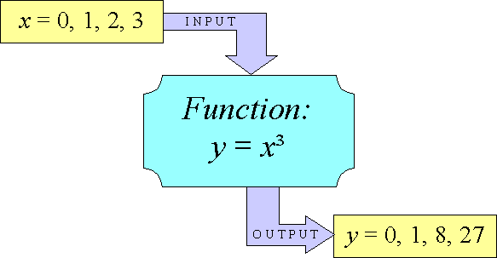

Functions Absolute & Relative Maximum and Minimum Values

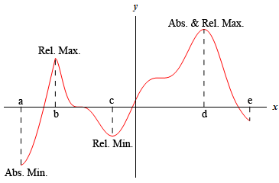

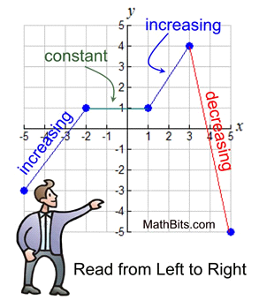

**Functions Inputs (X) and Outputs (Y)**

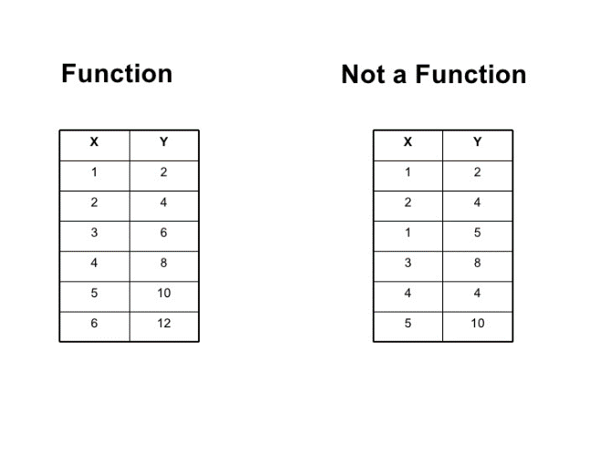

Functions Inputs (X) and Outputs (Y)

Example: When using functions, for a given X value, there is only 1 Y value. So if I say X is 2, and f(2)=8, then f(2) can ONLY EQAUL 8. WE CAN’T PUT 2 INTO THE FUNCTION AND GET ANY OTHER VALUE THAN 8.

BUT f (546) can = 8, many values can equal 8, but f (2) can only have one value.

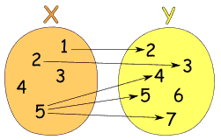

**Piecewise Functions**

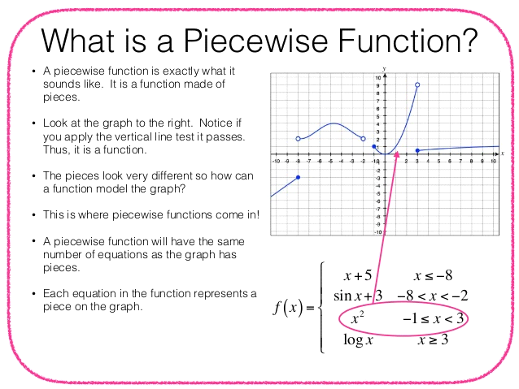

**Graphing Linear Functions (Graphing Straight Lines)**

First things is the title. We should know Linear Functions form straight lines!!!!

We know a function is linear if there are no exponents attached to any variables.

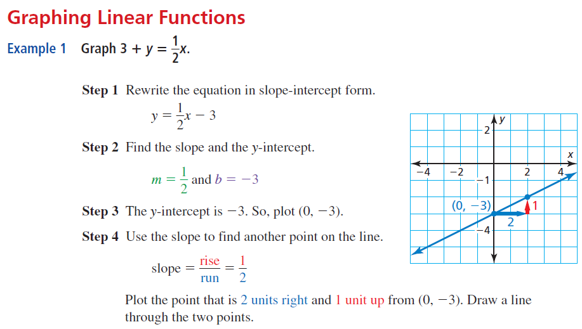

**Solutions to Systems and Solving by Graphing**

How do we find the solution?

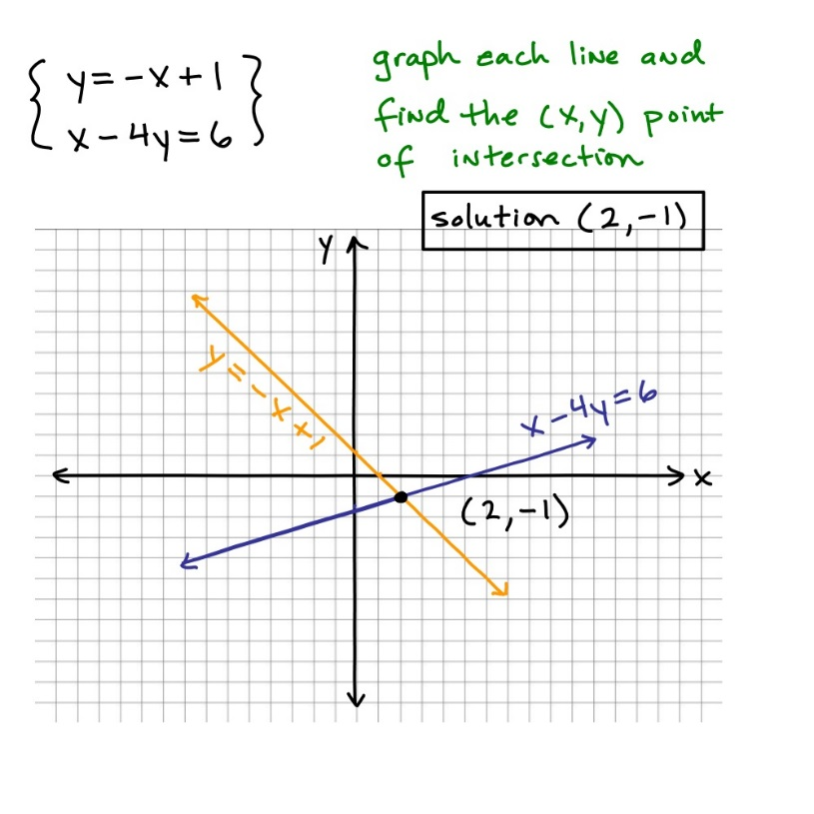

**Another example….**

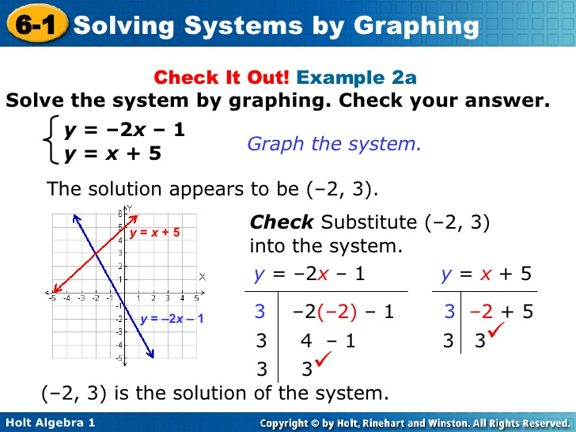

**Solutions to Systems and Solving by Graphing Cont…**

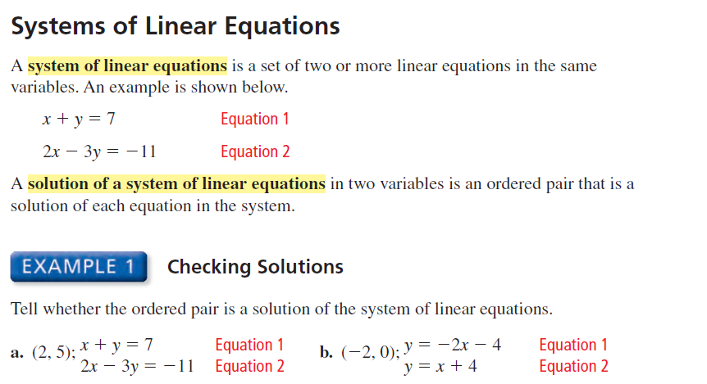

**You Try! Graph both equations on one graph!!!**

[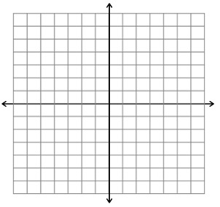](https://www.google.com/url?sa=i&rct=j&q=&esrc=s&source=images&cd=&cad=rja&uact=8&ved=0ahUKEwiy6pfTs7jYAhVhct8KHV27APoQjRwIBw&url=https://mathbits.com/MathBits/StudentResources/GraphPaper/GraphPaper.htm&psig=AOvVaw1aZ2N_Hop4181bUqxfq57M&ust=1514952408899169)**A)**

**Equation**

**Equation**

[](https://www.google.com/url?sa=i&rct=j&q=&esrc=s&source=images&cd=&cad=rja&uact=8&ved=0ahUKEwiy6pfTs7jYAhVhct8KHV27APoQjRwIBw&url=https://mathbits.com/MathBits/StudentResources/GraphPaper/GraphPaper.htm&psig=AOvVaw1aZ2N_Hop4181bUqxfq57M&ust=1514952408899169)

**B)**

**Equation**

**Equation**

**Extra Practice 1 and 2**

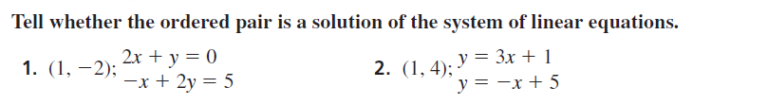

**You Try! Graph both equations on one graph!!!**

[](https://www.google.com/url?sa=i&rct=j&q=&esrc=s&source=images&cd=&cad=rja&uact=8&ved=0ahUKEwiy6pfTs7jYAhVhct8KHV27APoQjRwIBw&url=https://mathbits.com/MathBits/StudentResources/GraphPaper/GraphPaper.htm&psig=AOvVaw1aZ2N_Hop4181bUqxfq57M&ust=1514952408899169)**1)**

**Equation**

**Equation**

[](https://www.google.com/url?sa=i&rct=j&q=&esrc=s&source=images&cd=&cad=rja&uact=8&ved=0ahUKEwiy6pfTs7jYAhVhct8KHV27APoQjRwIBw&url=https://mathbits.com/MathBits/StudentResources/GraphPaper/GraphPaper.htm&psig=AOvVaw1aZ2N_Hop4181bUqxfq57M&ust=1514952408899169)

**2)**

**Equation**

**Equation**

|  |  |
| --- | --- |
| **Check Algebraically (Check with numbers and formulas-AKA🡪 Math** | |
| **1)**  **Equation**  **Equation** | **2)**  **Equation**  **Equation** |

**Solving Systems by Substitution**

We are finding the values of x and y that make BOTH equations TRUE. Which means if we get something like 5 = 9 (WRONG) we know that's not true and those value are not solutions.

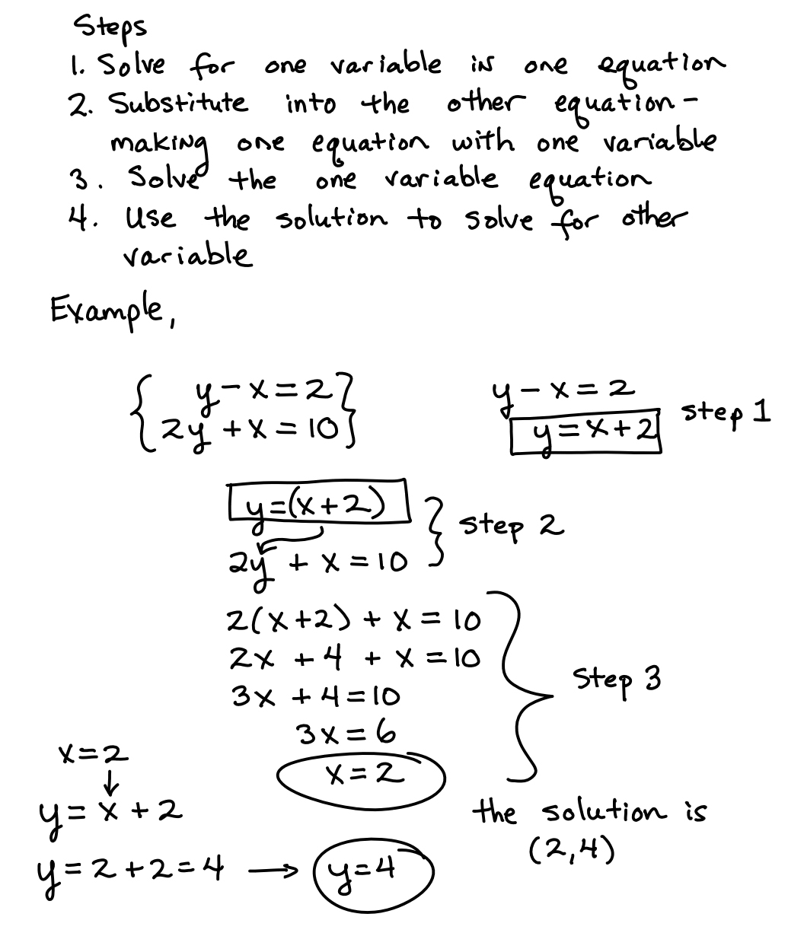

**Solving Systems by Substitution**

Here is another example. The arrow shows how we substitute in x + 1 instead of Y. That leaves an equation with one variable that we can solve.

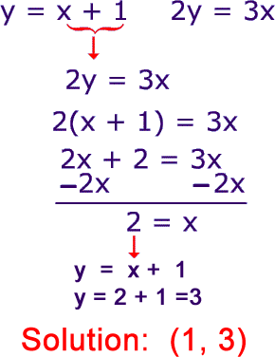

**Properties of system and their solutions**

Sometimes we use the facts we know about equivalence to make things easier. Knowing the properties of systems will help you have a better understanding of how everything is connected. I have to warn you, this video is loooooong. The point is that it is very thorough and explains a lot. You can also rewind and pause, etc...

[**Video: https://www.youtube.com/watch?v=Q9YqsANbWEE**](https://www.youtube.com/watch?v=Q9YqsANbWEE)

**The Elimination Method**

We eliminate one of the variables by adding the equations together,,,,

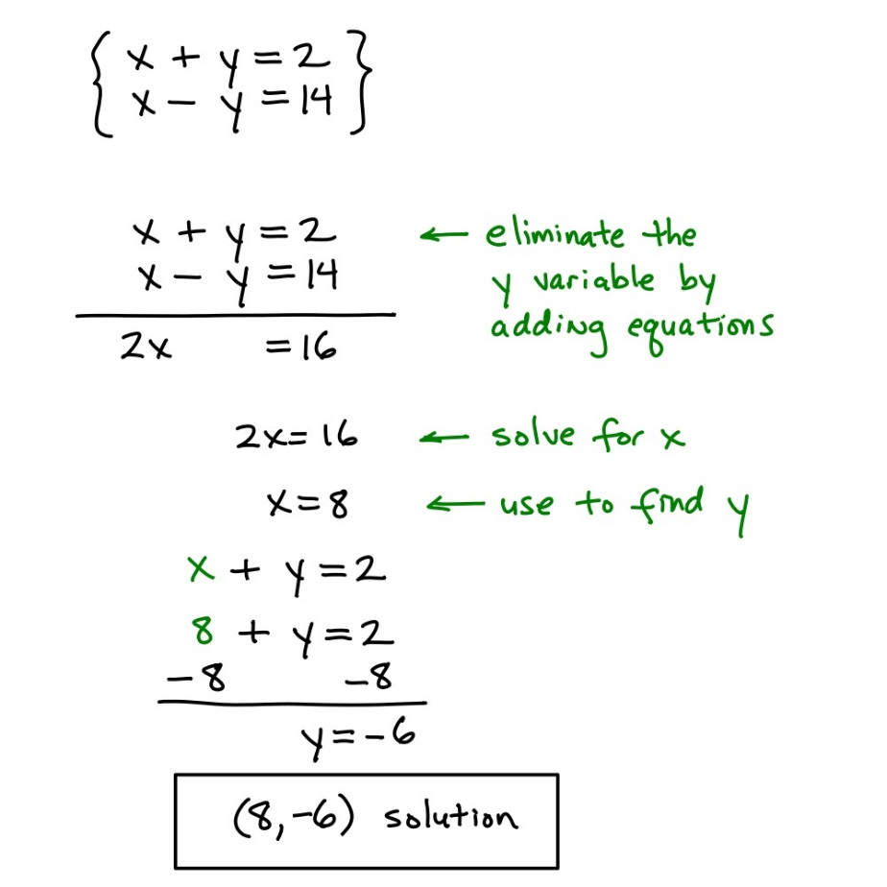

Here we use the multiplication property to make things easier. Then we use the elimination method to get to a point where we only have one variable.... We would then solve for y, and substitute that value into one of the original equations to find the value of X.

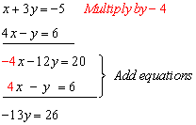

**Practice Solving Systems of Equations**

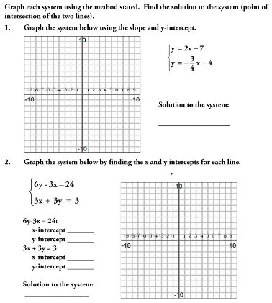

**Modeling with systems of equations**

Modeling with systems really means, when can we use these skills in real life. The whole point of learning math is to be able to learning how and when to apply these skills in real life! Using systems of equations really can help you make financial decisions. For example, below is an example of graphs we could be looking at when choosing a cell phone plan.

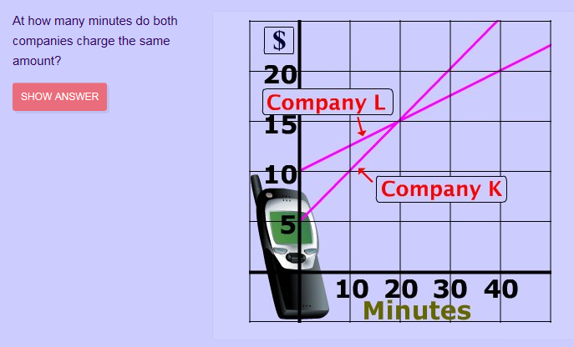

**Ms. Bloom's Suggestions:**

-Make a table of values. This will help you graph the system and see any patterns.

-Graph it on your calculator! Use the fabulous tools you have to graph the function to make sure it looks correct

Another video with Kirk about modeling real life problems with systems of equations. I hope you are watching these, they are really helpful. :)

[Video: https://www.youtube.com/watch?v=dion-eXqBUs](https://www.youtube.com/watch?v=dion-eXqBUs)

**Solving Equations Graphically**

The solution(s) to any system is where they intersect, or overlap. There are few scenarios here.

**Scenario 1: We could have 1 point** that is the solution, like below, the only solution is the one exact point (2,1).

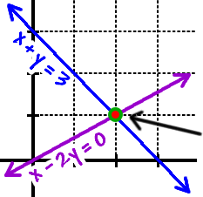

**Scenario 2: We could have Infinite Solutions.** This happens when one equation is a multiple of the other.Where they intersect, like below, the lines are on top of one another. They literally have the same exact solutions and the possibilities are infinite.

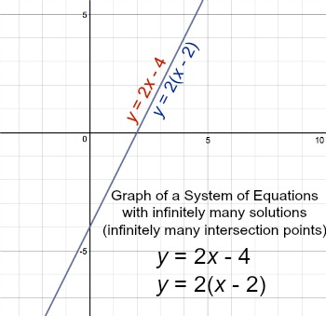

**Solving Equations Graphically Continued…**

**Scenario 3: We could NO SOLUTION**, like below, the lines never intersect, in no world does x + y = 1, then again x + y = 4. If we state X+Y equals something, it has to equal the same thing, the fact that we are stating it has a solution has to be true. There is no solution (point) that makes both statements true at the same time.

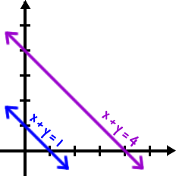

**Solving Equations Graphically-** The Short Version: Below is a picture that summarizes all three possibilities.

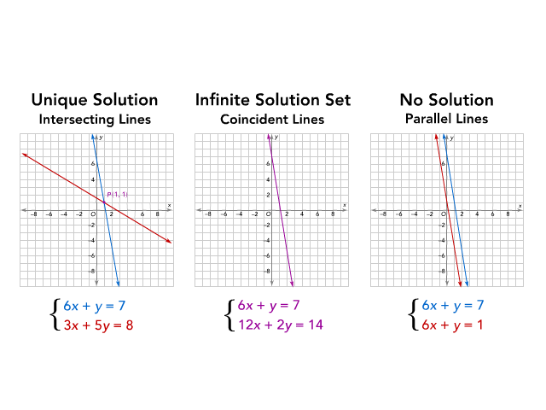

**Solving Systems of Inequalities**

When we graph inequalities the area where the graphs overlap is the solution set. In the problem below we can test points in the green area and they should all be true. For example the point (3,-1) makes both inequalities true, because that is one of the points that is in the green area. The point (4,-2) also works, any point in the green area will work.

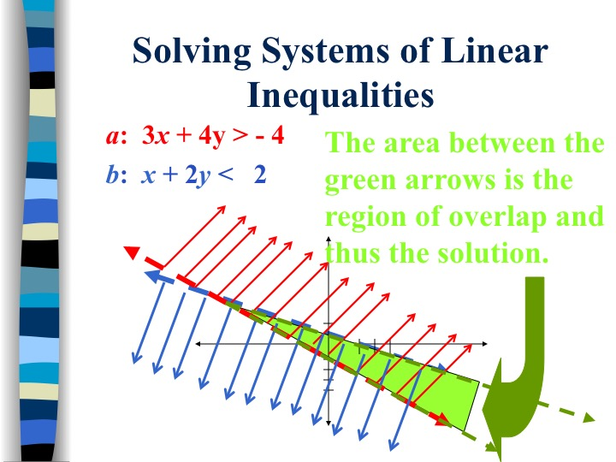

**Modeling with Systems of Inequalities**

Again we can model real life examples with systems of inequalities just like we can with equations. In real life companies are concerned about profit and what point they start making money instead of only spending it to keep the company running.

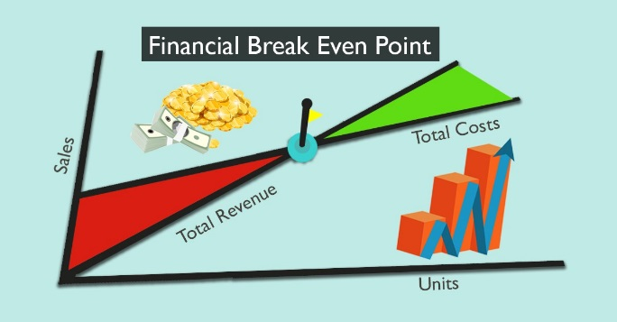

**Name: _______________________ Date: ___________**

**Systems of Equations and Inequalities Organizer**

**Task:____________________________** **Problem # _______**

**Equation 1 ________________ ___**

**Equation 2____________________ Work Space**



|  |
| --- |
| Check Solutions |